Experimental Results and Figure Summary 实验结果与图表总结
Part I. Full Experimental Results 全部实验结果（18 Figures）
Fig. 1. AE training curve — 自编码器训练曲线
说明：Training and validation loss decrease steadily, showing convergence of the autoencoder model.
解读：训练与验证误差稳定下降，说明AE模型成功收敛。
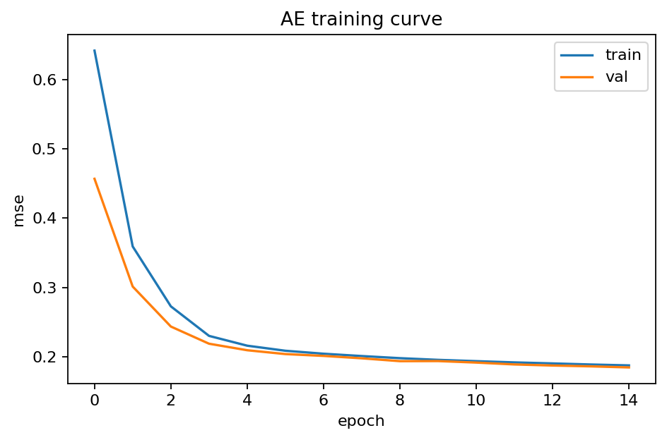
Fig. 2. Alerts/hour (count of records) — 每小时警报数量
说明：Periodic hourly pattern observed across multiple days, suggesting cyclical workload.
解读：多日内呈周期性波动，反映系统负载随时间的规律性变化。
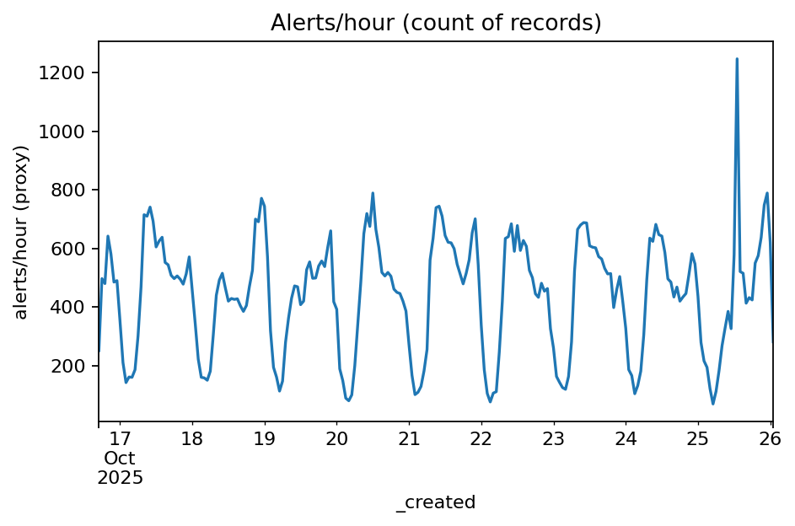
Fig. 3. Boxplot by category (top-8) — 各部门响应时间箱线图
说明：Response time distribution varies by agency, indicating operational differences.
解读：不同部门响应时间差异明显，体现运维效率不均。
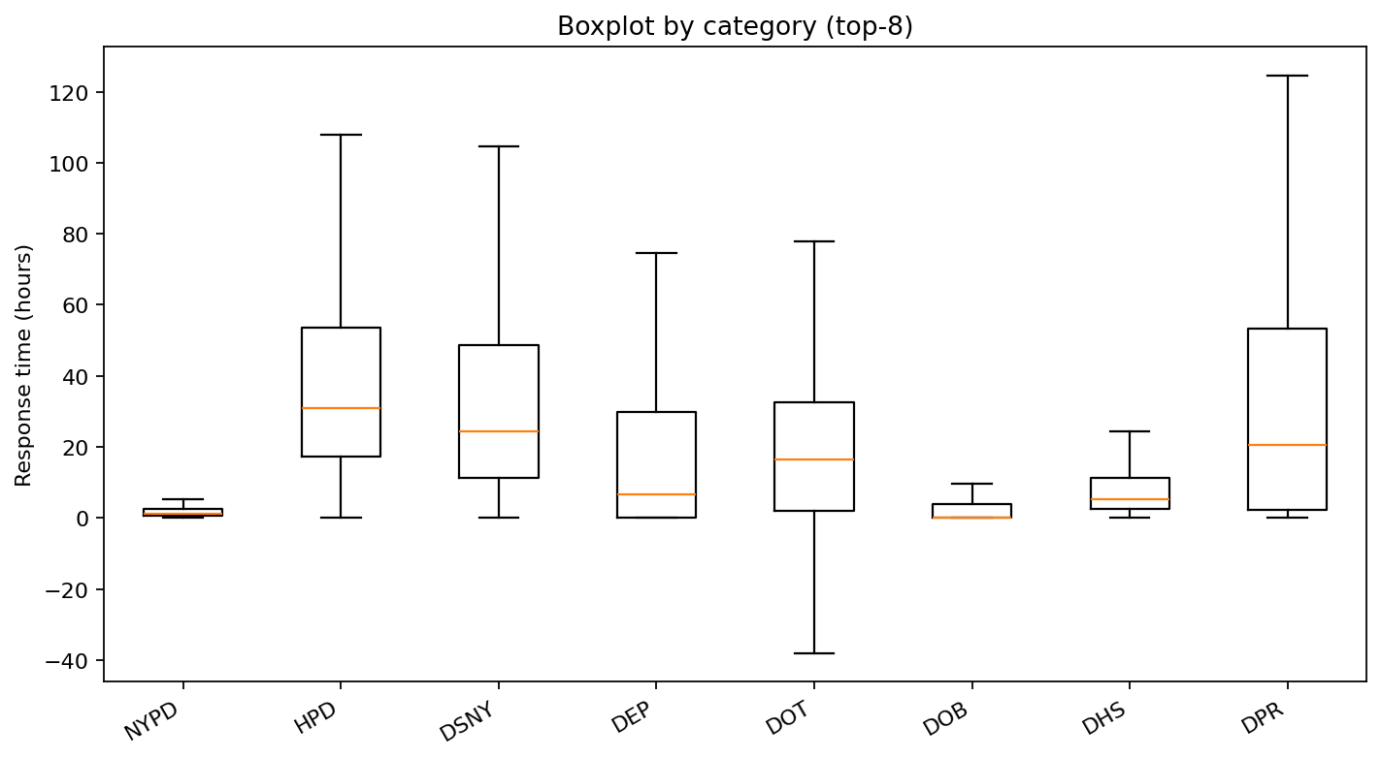
Fig. 4. Category distribution (top-8) — 类别占比饼图
说明：Most records belong to NYPD and HPD categories, showing data imbalance.
解读：数据集中主要来自NYPD与HPD，存在显著类别不平衡。
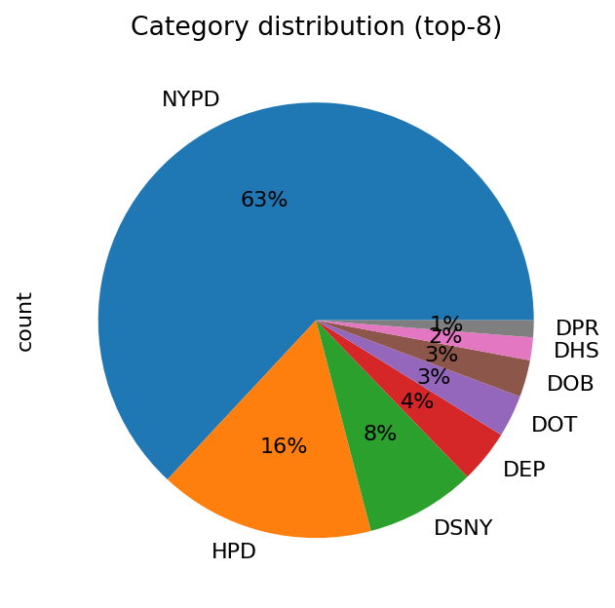

Fig. 5. Confusion Matrix – IF 模型混淆矩阵
说明：Isolation Forest confusion matrix showing balanced detection with moderate false positives.
解读：IF模型在检测准确率与召回率间表现平衡，误报率适中。
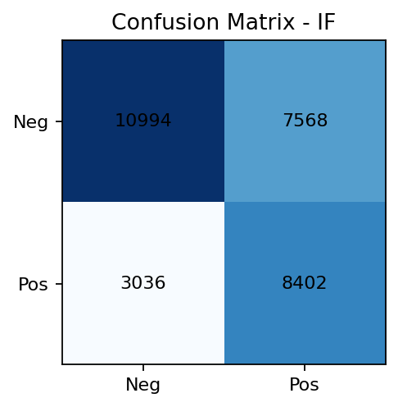
Fig. 6. Heatmap: count by weekday-hour — 每周每日小时分布热力图
说明：Higher request frequency observed on weekdays, especially midday and Friday afternoons.
解读：请求高峰集中在工作日午间与周五下午，呈明显周期特征。
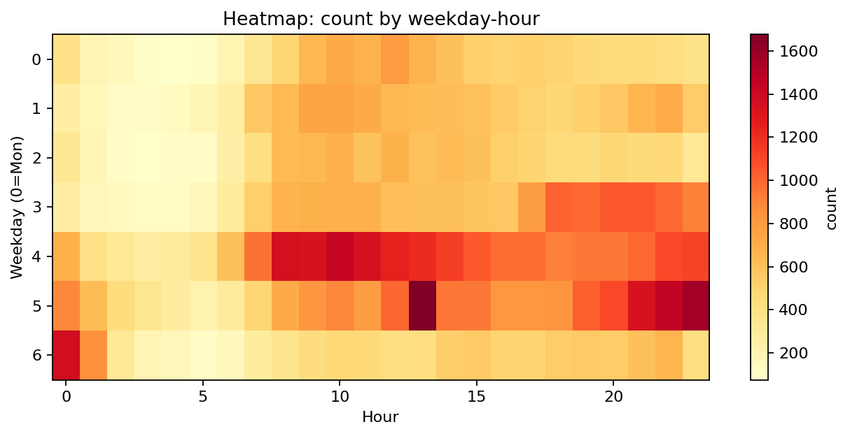
Fig. 7. Histogram of response time — 响应时间直方图
说明：Response times are right-skewed, with most requests resolved within 20 hours.
解读：响应时间分布右偏，大部分任务在20小时内完成。
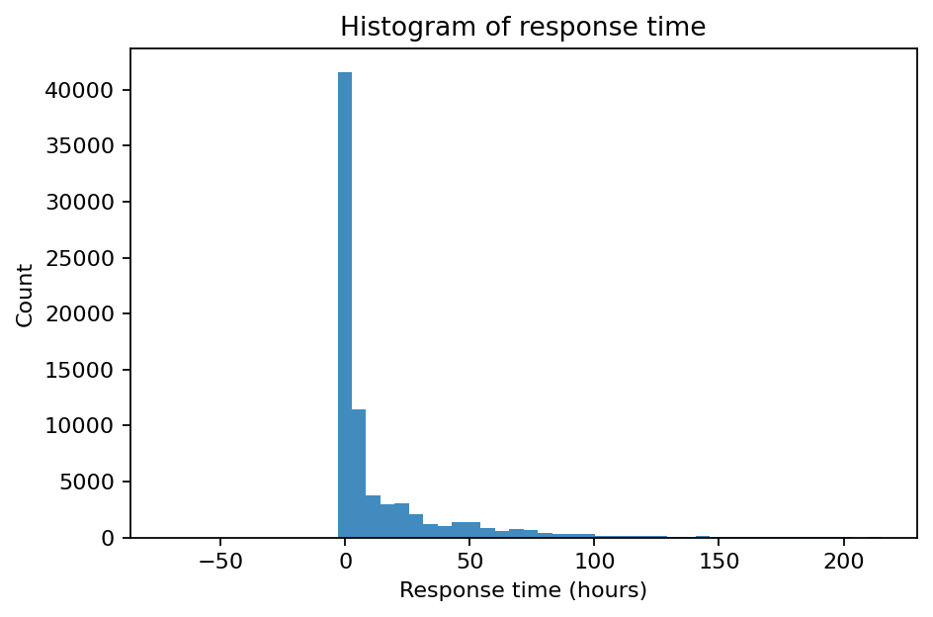
Fig. 8. KDE of response time — 响应时间核密度估计
说明：Kernel density plot confirms the skewness and long-tail behavior.
解读：核密度曲线验证长尾分布特征，表明极端延迟事件存在。
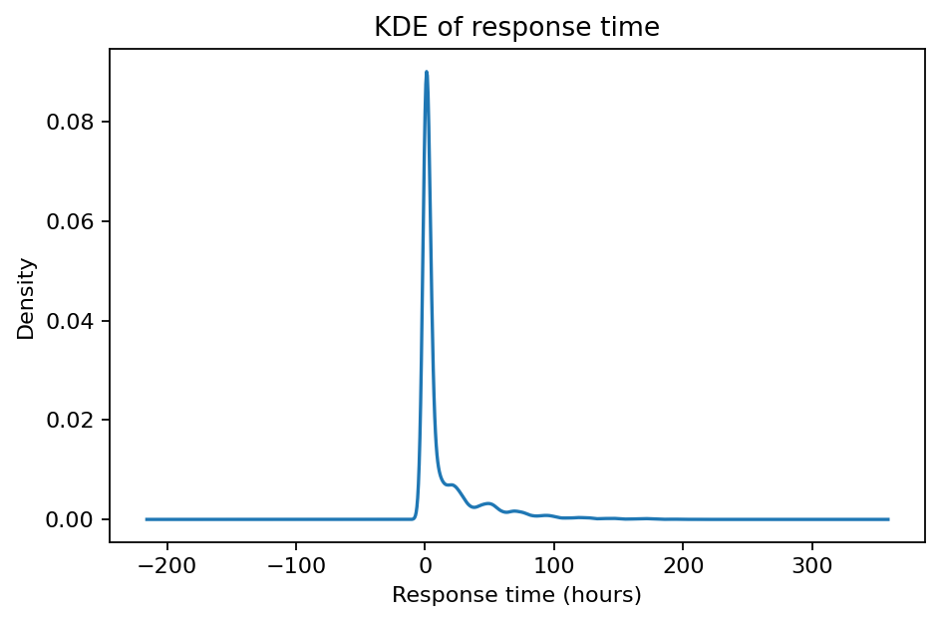
Fig. 9. Metrics comparison (mean ±95% CI) — 模型性能指标比较
说明：RF achieves near-perfect F1, while IF performs robustly under limited data.
解读：RF模型表现接近完美；IF在有限数据下仍表现稳健。
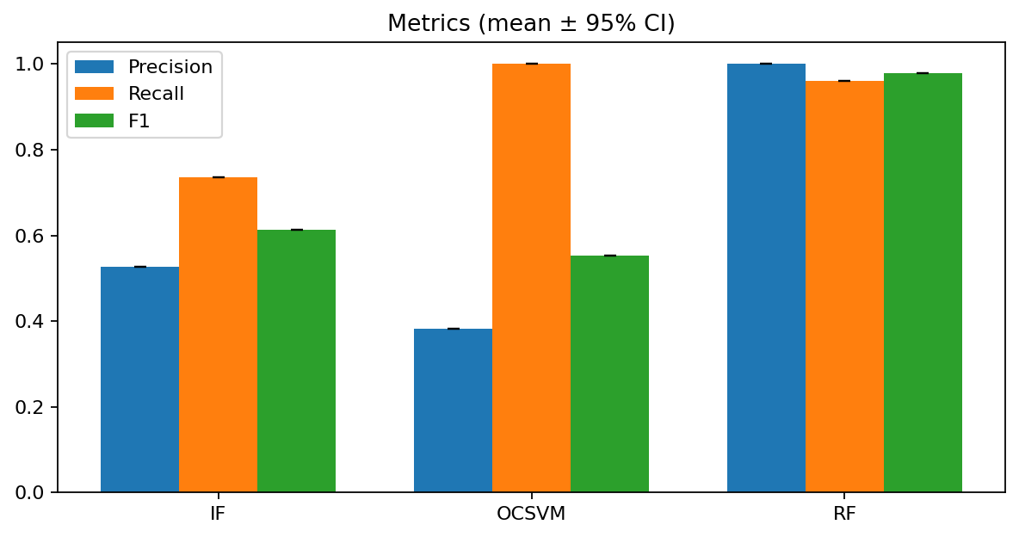
Fig. 10. Ops trade-off (precision vs recall) – IF
说明：Precision decreases smoothly as recall increases, indicating controllable threshold behavior.
解读：IF模型Precision与Recall的反向变化体现阈值可调性。
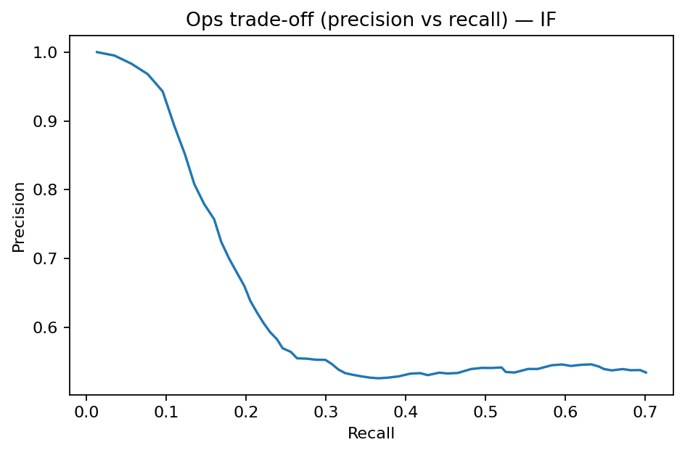
Fig. 11. Ops trade-off – OCSVM
说明：OCSVM precision drops quickly, showing sensitivity to noise.
解读：OCSVM模型对噪声敏感，Precision下降明显。
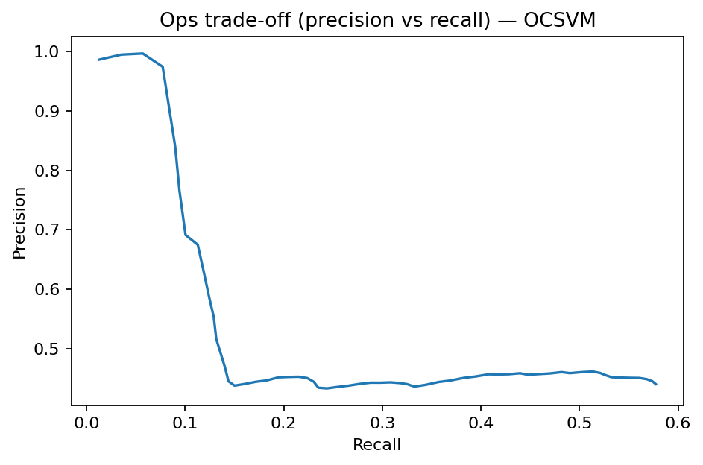
Fig. 12. Ops trade-off – RF
说明：RF maintains nearly perfect precision and recall across thresholds.
解读：RF在各阈值下保持高精度与高召回，稳定性最佳。
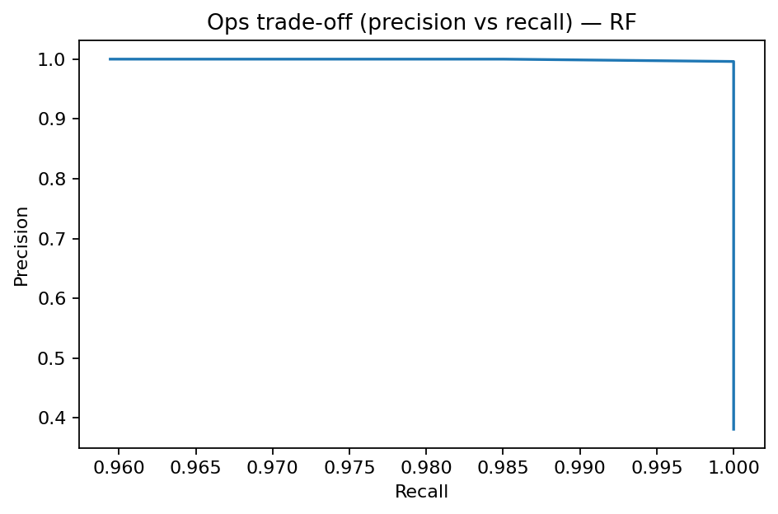
Fig. 13. Precision–Recall curves (IF/OCSVM/RF)
说明：RF achieves AP=1.000, outperforming IF (0.588) and OCSVM (0.471).
解读：RF模型几乎完美检测，IF稳健，OCSVM略逊。
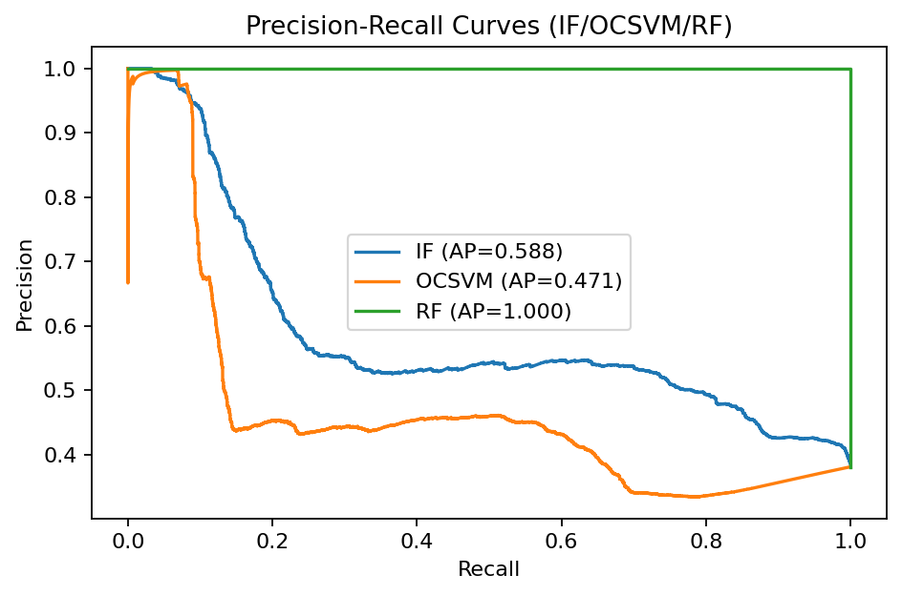
Fig. 14. PR curves with AE — 含自编码器的PR曲线
说明：AE shows moderate performance (AP=0.421) and complements IF in unsupervised mode.
解读：AE虽性能较低，但在无监督条件下提供有效补充。
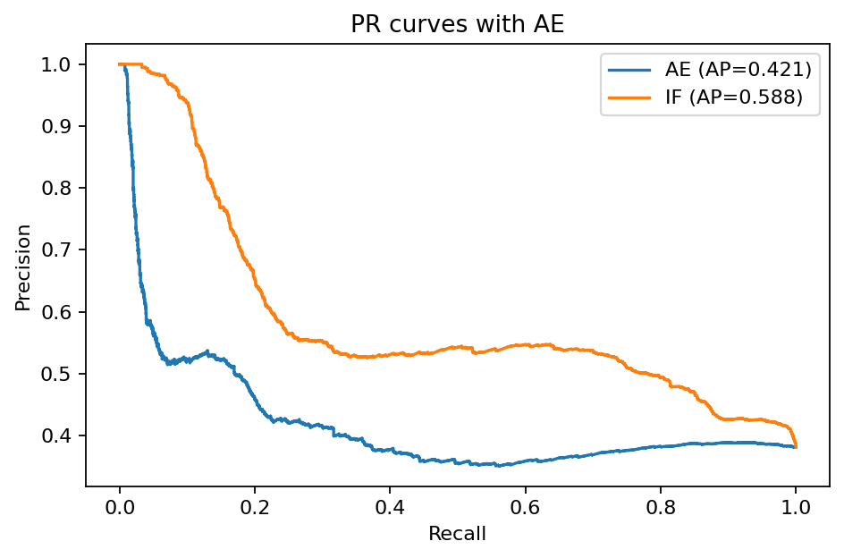
Fig. 15. RF Feature Importances — 特征重要性分析
说明：Response time dominates model influence, followed by agency category.
解读：响应时间（resp_h）贡献最大，部门类别影响次之。
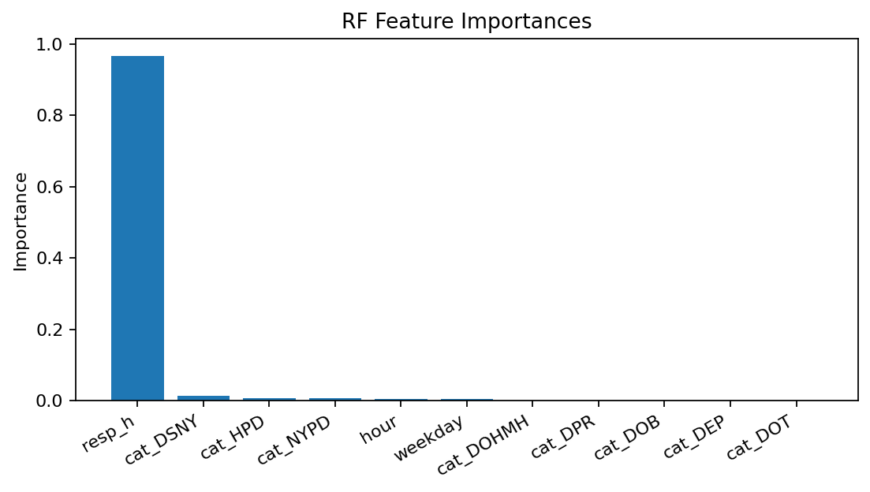
Fig. 16. SHAP Bar Plot — 特征解释贡献图
说明：‘Hour’ and ‘Weekday’ are key explanatory variables driving anomaly predictions.
解读：时间特征对异常检测贡献突出，模型可解释性强。
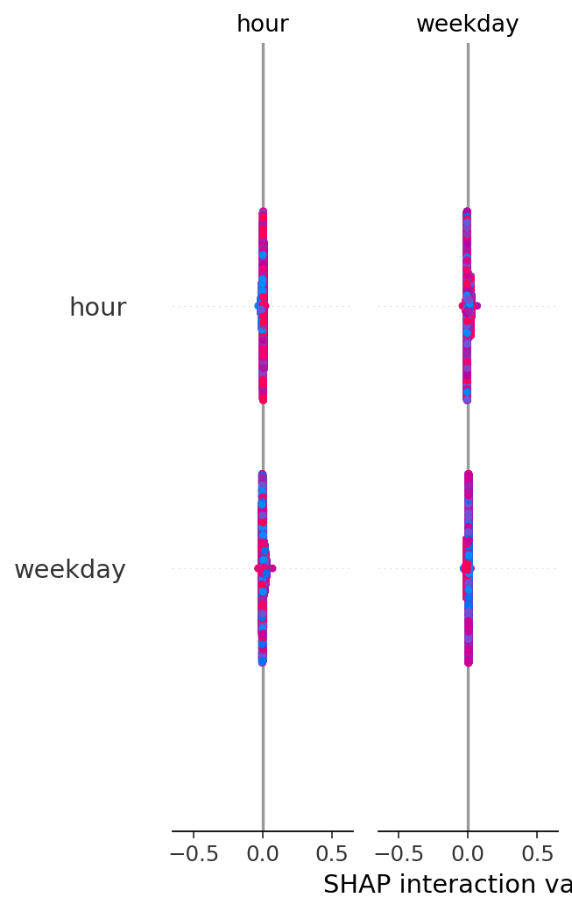
Fig. 17. SHAP Summary Plot — SHAP综合可解释图
说明：Hour and weekday effects appear largely independent, confirming temporal influence.
解读：时间特征间影响独立，揭示周期性异常规律。
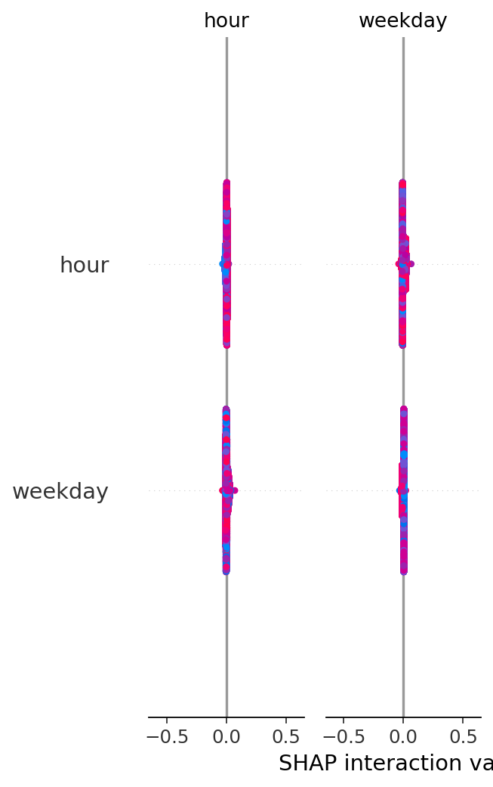

Fig. 18. Threshold sweep: IF — 阈值扫描分析
说明：F1 peaks near threshold −0.08, providing an optimal runtime configuration.
解读：F1在阈值−0.08附近达到最优，适合作为运行警报参数。
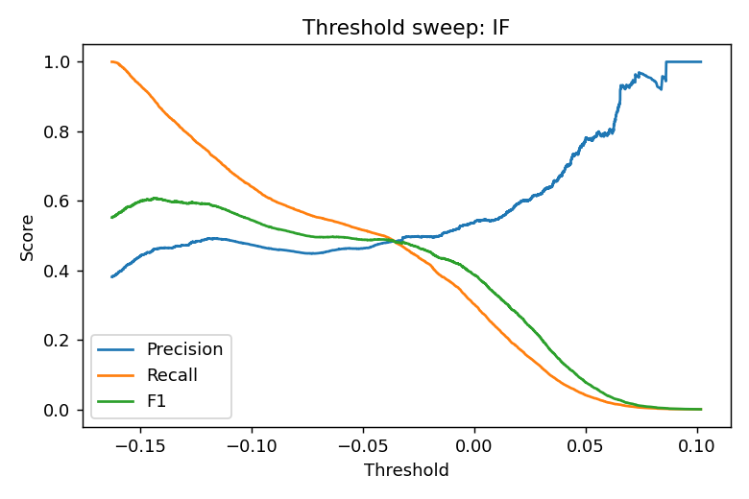
Part II. Core Figures and Table 核心展示图表（主论文使用）
These are the essential 7 figures and 1 table that form the paper’s main experimental narrative.
以下图表为建议保留在正文的主要部分：
- Fig. 1. AE training curve — Shows convergence and model stability.
- Fig. 6. Heatmap by weekday-hour — Visualizes workload periodicity.
- Fig. 9. Metrics comparison (mean ±95% CI) — Summarizes quantitative results.
- Fig. 13. PR curves (IF/OCSVM/RF) — Core model comparison visualization.
- Fig. 15. RF Feature Importances — Shows interpretability and key drivers.
- Fig. 16. SHAP Bar Plot — Enhances explainability analysis.
- Fig. 18. Threshold sweep: IF — Demonstrates parameter sensitivity.
- Table I. summary_metrics.csv — Consolidated metrics summary.
Why these are essential:
They establish a full logical chain — from data pattern → model performance → interpretability → optimization — while fitting in 2–3 pages (ideal for ACM/IEEE proceedings).
Part III. Supplementary Figures and Tables 附录与补充图表
These figures/tables support secondary findings and can be included in the appendix or online repository.
- Fig. 2. Alerts/hour — Temporal density visualization.
- Fig. 3. Boxplot by category — Cross-agency delay distribution.
- Fig. 4. Category pie — Class imbalance evidence.
- Fig. 5. Confusion Matrix - IF — Diagnostic analysis.
- Fig. 7. Histogram of response time — Complementary distribution view.
- Fig. 8. KDE of response time — Smoothed statistical representation.
- Fig. 10–12. Trade-off curves (IF, OCSVM, RF) — Threshold sensitivity exploration.
- Fig. 14. PR curves with AE — Unsupervised extension results.
- Fig. 17. SHAP Summary Plot — Advanced interpretability illustration.
- Table II. real_calls_clean.csv — Cleaned dataset subset for reproducibility.
Note:
These materials can be moved to Appendix A–C or to an external repository (e.g., GitHub / Zenodo) for transparency and reproducibility.

